**Requirements Specification Document**

**( GROUP - 5 )**

# 1. Project Summary

## 1.1 Project Overview

The Ecommerce Web Application includes a login page that allows users to create accounts or log in to their existing accounts. The login functionality enables users to personalize their experience, add items to their Wishlist, and make a seamless transition to the payment process. The Ecommerce Website is a web-based application that aims to provide users with a convenient platform for browsing and shopping for various products such as clothing, accessories, and more. The website features a homepage that showcases different categories. It provides a visually appealing and easy-to-navigate interface that allows users to browse through the available products in each category.

## 1.2 Project Scope

The Ecommerce web application provides a secured platform for the people around the world they can login with a username and a password they can buy the products that are needed to them. The Web app offers a wide range of products, ensuring a diverse selection for users with varying preferences. The project incorporates hot offers and deals, highlighting special discounts and promotions on selected items. This feature aims to attract users' attention and encourage them to explore the app further.

Once the user visits the Ecommerce Website, the users encounter a login page for account creation or login. Successful authentication grants access to personalized features and preferences. The Logged in, users land on the homepage showcasing categories (men's, women's, children's, accessories), enabling easy navigation. Hot offers and deals catch users' attention, encouraging further exploration. While exploring products, users can click on items to view detailed information (images, descriptions, prices, sizes) for informed decisions. To enhance shopping, users can add products to their Wishlist, facilitating future access and tracking. Selected products lead users to the payment process. They select payment methods, and confirm orders. Though the project focuses on the frontend, it ensures a seamless, secure checkout experience.

## 2.0 General Description

The Ecommerce Website (frontend only) project aims to provide users with an intuitive and user-friendly platform for browsing and shopping for a wide range of products. The website features a visually appealing and easy-to-navigate interface, showcasing different categories such as men's, women's, children's, and accessories. Users can explore these categories to find desired products, view detailed information including images, descriptions, prices, and sizes, and take advantage of hot offers and deals. The project also includes a login page for account creation and login, allowing users to personalize their experience, add products to their Wishlist, and seamlessly transition to the payment process.

## 2.1 Product Functions Overview

**Types of users/actors:**

Everyone the around World can use this website it provides all the necessary items to them.

**User features:**

1.The Users can create new accounts or log in to access personalized features and proceed smoothly through the payment process.

2.The website will have a visually appealing and user-friendly interface displaying categories for easy navigation.

3.The User will get Detailed product information, including images, descriptions, prices, sizes and reviews, will be provided for users to explore.

4.Even the user gets a Hot page as a dedicated section that will showcase attractive deals and promotions on selected products.

5.Logged-in users can add products to their Wishlist for future reference and a personalized shopping experience.

6.The website will guide users through the payment process until payment confirmation, ensuring a smooth transition from product selection to payment.

## 2.2 User Interface Design

## Sign in Page:

## 

: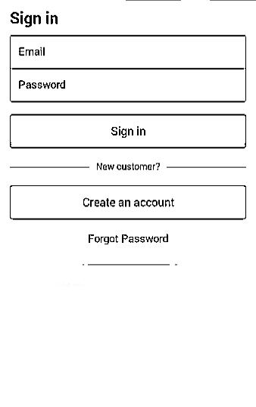

WEBSITE HOMEPAGE:

## 

BLOCK DIAGRAM / PROCESS TO ORDER A PRODUCT: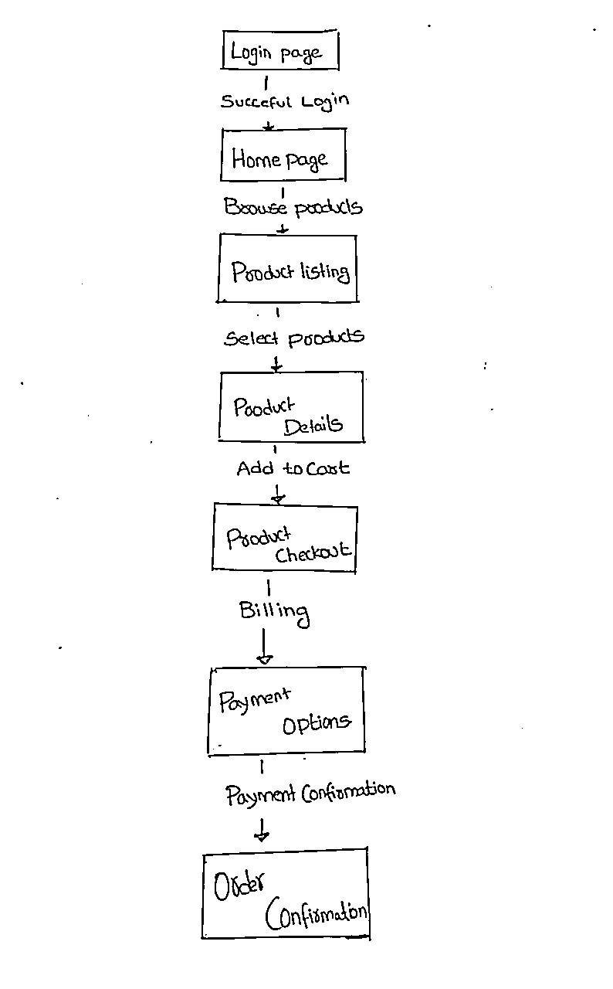

## 2.3 Link to the developer’s website

* A Koti Reddy(22004) - <https://a-koti.github.io/Resume.github.io/>
* DVSS Swapnith (22016) - <https://swapnith07.github.io/Resume.git.io/>
* Vardhan Reddy(22018) - https://vardhanreddy9.github.io/portFolio.github.io/
* M Leela Naresh(22030) - https://chinnuykc.github.io/portFolio.github.io/
* Kireeti (22037) - https://soulreaper007h.github.io/Resume.git.io/